**Mini Assignment-DBT Lakshmi Harish Kumar**

Created new database, schema, role and all in snowflake and done dbt init for connection.

For loading the xml files given to us, used snowsql and tried. But it shows the following error and failed to load.

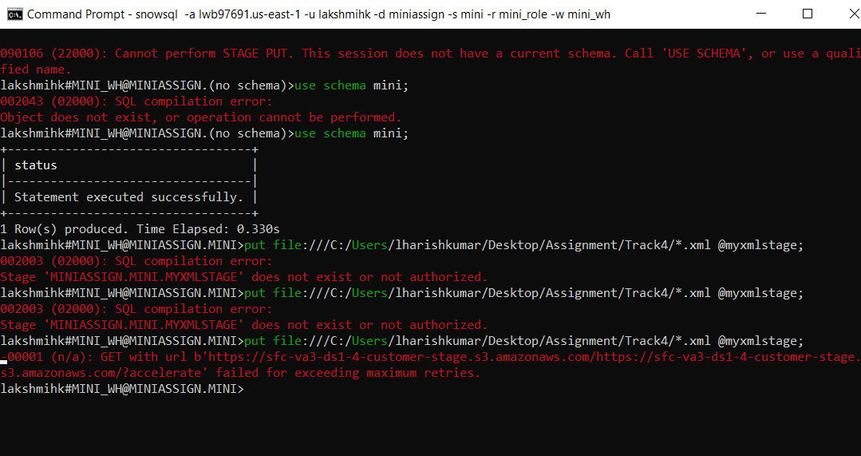

Then tried to make each files short by using python code. It reduces the line of code to 1000 and make a csv file. Since I found loading csv files in snowflake is comparatively easier than xml file. Because xml file loaded must be parsed in a format to get the correct table. So tried this python code. But when doing this code with larger files first need to copy paste it into other xml files, since it shows error. Then tried, 3 of the files successfully reduced and changed to csv format. But the rest shows the following error.

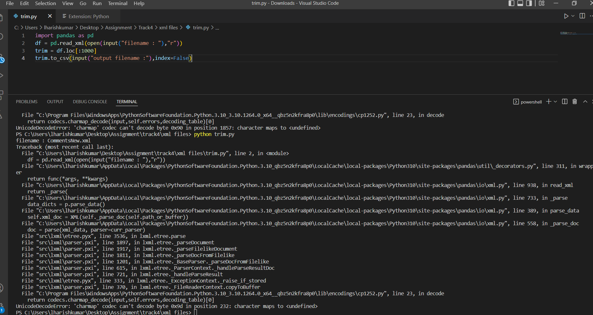

Then I tried using manual methods for uploading for the rest of xml files to snowflake.